Content 8

**Functions And Recursions**

A function is a group of statements performing a specific task.

When a program gets bigger in size and its complexity grows, it gets difficult for a programmer to keep track of which piece of code is doing what!

A function can be reused by the programmer in a given program any number of times.

**Example and Syntax of a function**

The syntax of a function looks as follows:

def func1():

print(“Hello”)

This function can be called any number of times, anywhere in the program.

**Function call**

Whenever we want to call a function, we put the name of the function followed by parenthesis as follows:

func1()          #This is called function call

**Function definition**

The part containing the exact set of instructions that are executed during the function call.

**Quick Quiz:**Write a program to greet a user with “Good day” using functions.

##### **Types of functions in Python**

There are two types of functions in Python:

1. Built-in functions #Already present in Python
2. User-defined functions #Defined by the user

Examples of built-in function includes len(), print(), range(), etc.

The func1() function we defined is an example of user-defined function.

**Functions with arguments**

A function can accept some values it can work with. We can put these values in the parenthesis. A function can also return values as shown below:

def greet(name):

gr = “Hello” + name

return gr

a = greet(“Harry”) #“Harry” is passed to greet in name

# a will now contain “Hello Harry”

**Default Parameter Value**

We can have a value as default argument in a function.

If we specify name = “stranger” in the line containing def, this value is used when no argument is passed.

For Example:

def greet(name=’stranger’):

#function body

greet()                       #Name will be ‘stranger’ in function body(default)

greet(“Harry”)        #Name will be “Harry” in function body(passed)

##### **Recursion**

Recursion is a function which calls itself.

It is used to directly use a mathematical formula as a function. For example:

factorial(n) = n * factorial(n-1)

This function can be defined as follows:

def factorial(n):

if i == 0 or i == 1 : #Base condition which doesn’t call the function any further

return i

else:

return n*factorial(n-1) #Function calling itself

**This works as follows:**

The programmer needs to be extremely careful while working with recursion to ensure that the function doesn’t infinitely keep calling itself.

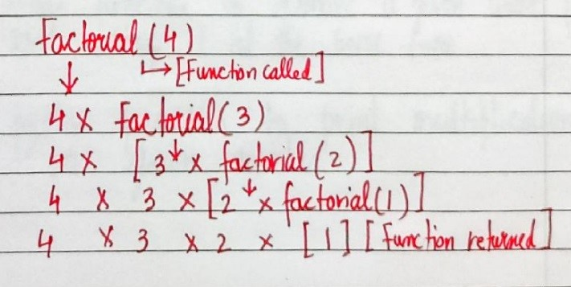

Recursion is sometimes the most direct way to code an algorithm.

**Code for factorial by Iterative and recursive approach:**

# Function for calculation factorial by iterative approach

def factorial_iterative(n1):

    product=1

    for i in range(n1):

        product=product*(i+1)

    return product

# By recursive approach

def recursion_factorial(n2):

    if n2==1 or n2==0:

        return 1

    return n2*recursion_factorial(n2-1)

n=int(input("Enter any number for factorial calculation: "))

f1=factorial_iterative(n)

print(f"This is the Answer by iterative approach:- {f1}")

f2=recursion_factorial(n)

print(f"This is the Answer by recursive approach:- {f2}")

Enter any number for factorial calculation: 5

This is the Answer by iterative approach:- 120

This is the Answer by recursive approach:- 120

**Code2 Find the greatest number of the three numbers:**

def maximum(n1,n2,n3):

    if n1>n3:

        g1=n1

    else:

        g1=n3

    if g1>n2:

        g=g1

    else:

        g=n2

    return g

num1=int(input("Enter a number 1: "))

num2=int(input("Enter a number 2: "))

num3=int(input("Enter a number 3: "))

f=maximum(num1,num2,num3)

print(f"The Greatest number of given three numbers is: {f}")

**Output:**

Enter a number 1: 12

Enter a number 2: 7

Enter a number 3: 4

The Greatest number of given three numbers is: 12

**Code3 for Srting:**

def creating_New(string, rmword):

    newstr = string.replace(rmword, "")

    return newstr.strip()   #for removing the blank space.

str1 = "     Shubham this is Sentence    "

n = creating_New(str1, "Shubham")

print("The new String is: ~~~",n)

**Output:**

The new String is: ~~~ this is Sentence

**Code4 For avoiding the next line:**

# Printing in one Line

print("How", end="")

print("are")

print("you?")

**Output:**

Howare

you?